WEB DEVELOPMENT ACTIVITY
Consolidated Report of GitHub Repository and Website Screenshots

Introduction
This report consolidates the submitted screenshots showing a GitHub repository and three web development activities. The repository is named WD-Activity-Based-Learning and contains HTML and CSS files. The website previews demonstrate the visible output of the Sweet Bakery, Adventure Trek, and Healthy Bites pages.

GitHub Repository
The GitHub screenshot shows a public repository owned by Tejayesupongu. The visible files include web activity1.html, web activity2.html, web activity3.html, 9th activity.css, 14th activity.css, 19th activity.css, and README.md. The repository page also shows the main branch and recent commits.

Activity 1 — Sweet Bakery Website
The Sweet Bakery website presents cakes, cookies, and pastries with product images and prices. It includes a special offer of 10% off custom cakes, contact information, and a footer. The page uses a brown header and footer with a light pink background and product cards.

Activity 2 — Adventure Trek Website
The Adventure Trek website introduces outdoor activities and trekking packages. The visible packages include Mountain Trek (medium difficulty, 2 days, ■1,999) and Forest Camping (easy difficulty, 1 day, ■999). It also displays an equipment checklist with a backpack, trekking shoes, and water bottle, plus safety guidelines.

Activity 3 — Healthy Bites Website
The Healthy Bites website presents food categories, healthy recipes, a daily meal plan, and healthy eating tips. Visible recipe cards include Vegetable Salad (180 kcal) and Healthy Oats (250 kcal). The meal plan lists oats for breakfast, rice, dal and vegetables for lunch, and roti with curry for dinner. The page uses a green header and a light green background.

Conclusion
The screenshots document the repository setup and the browser output of three HTML website activities. Together, they show basic web development concepts such as HTML page structure, images, content sections, product or activity cards, CSS styling, and page footers.

Appendix — Submitted Screenshots
The following pages preserve the submitted screenshots as visual evidence. Some screenshots show different scroll positions of the same website.

Screenshot 1: GitHub repository and uploaded activity files.
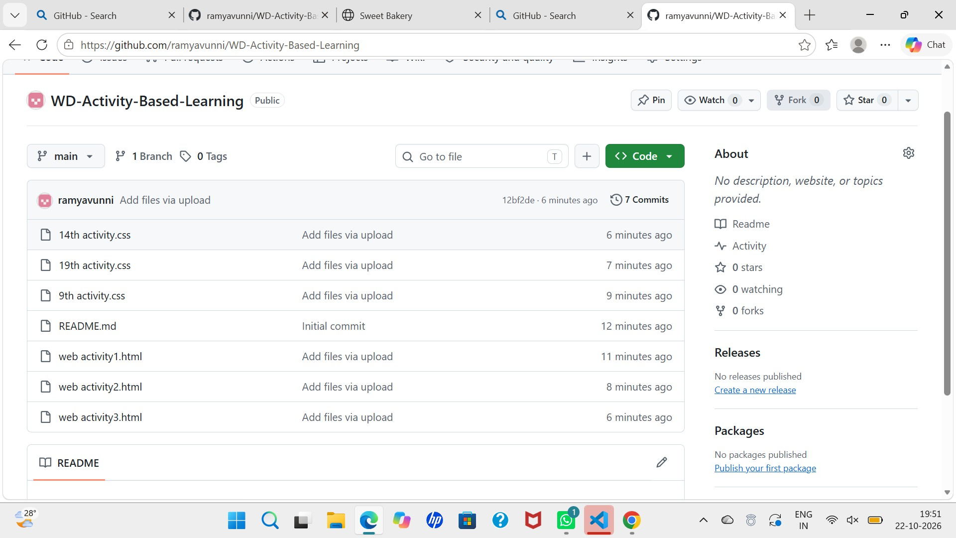

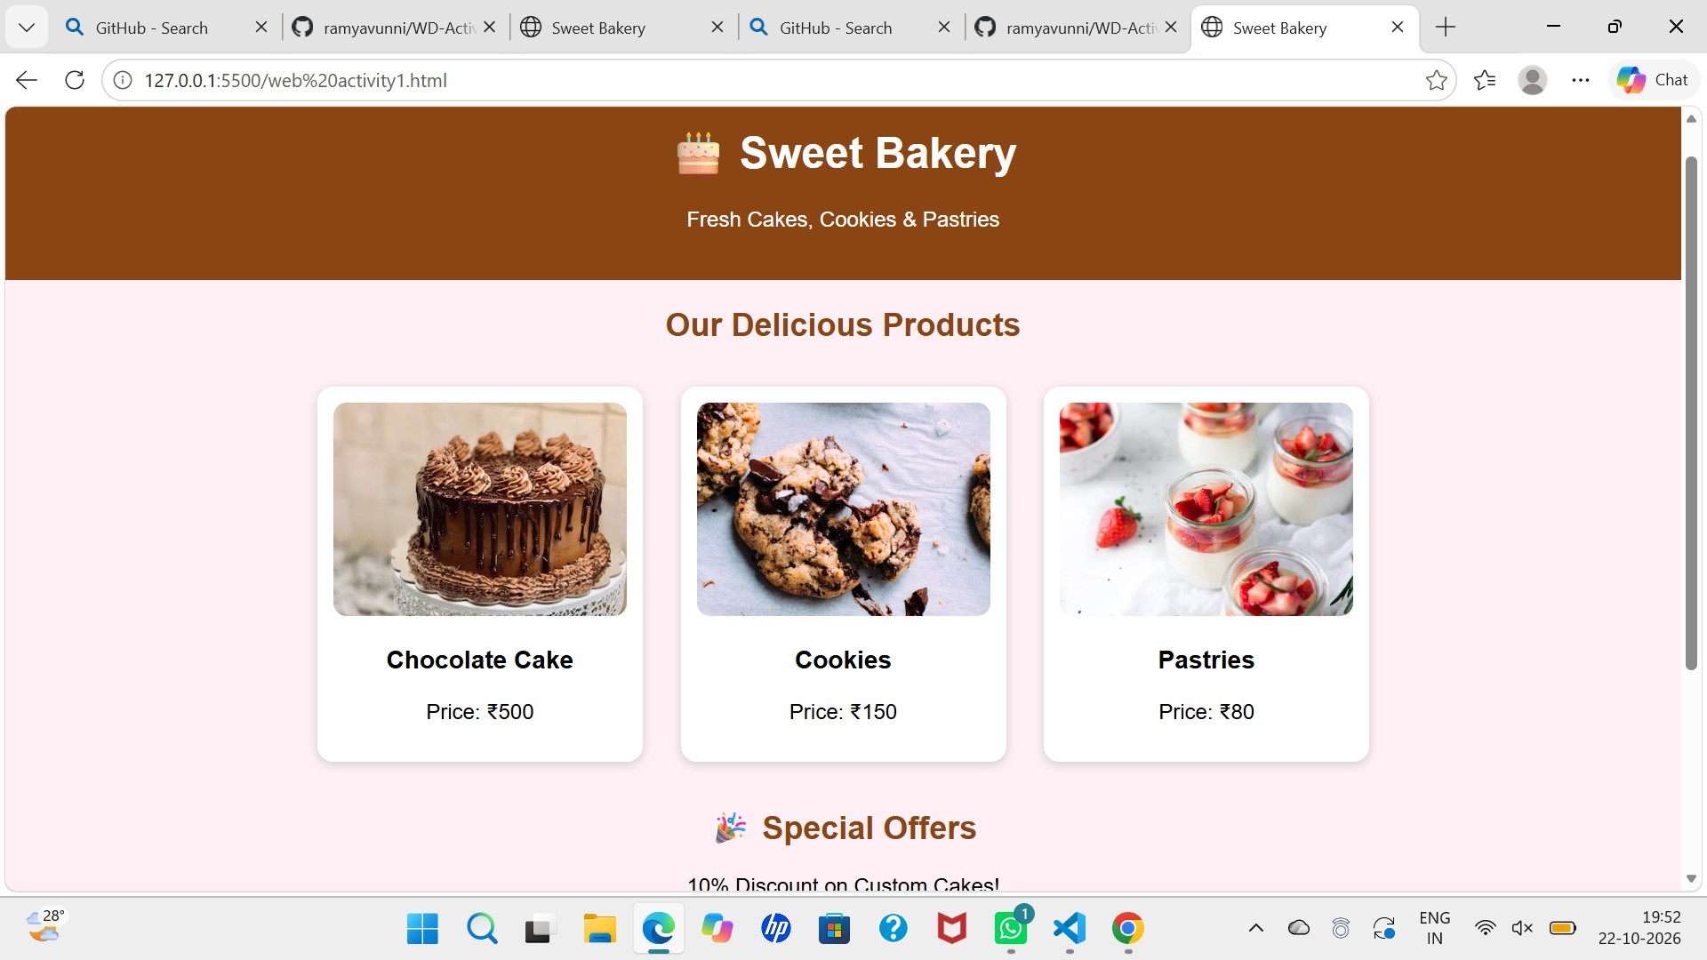

footer.
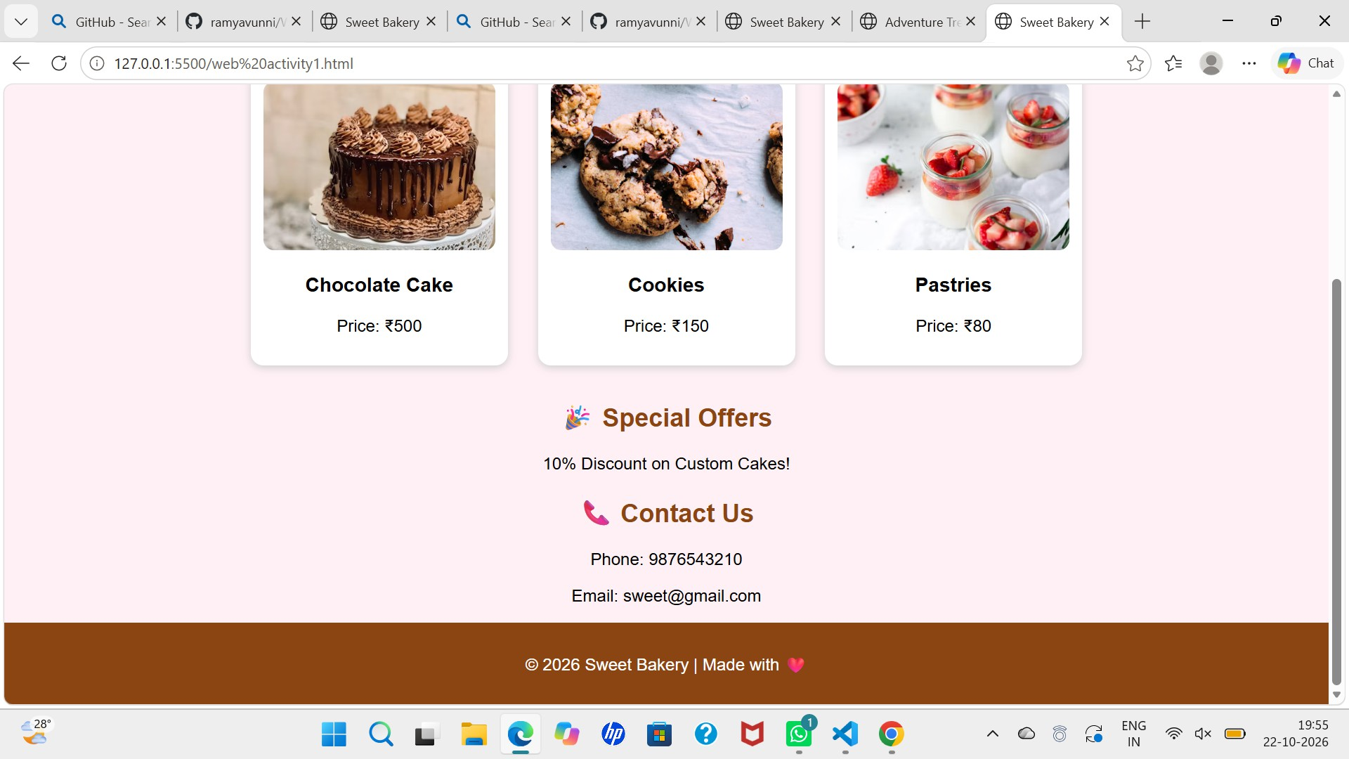

trekking package.
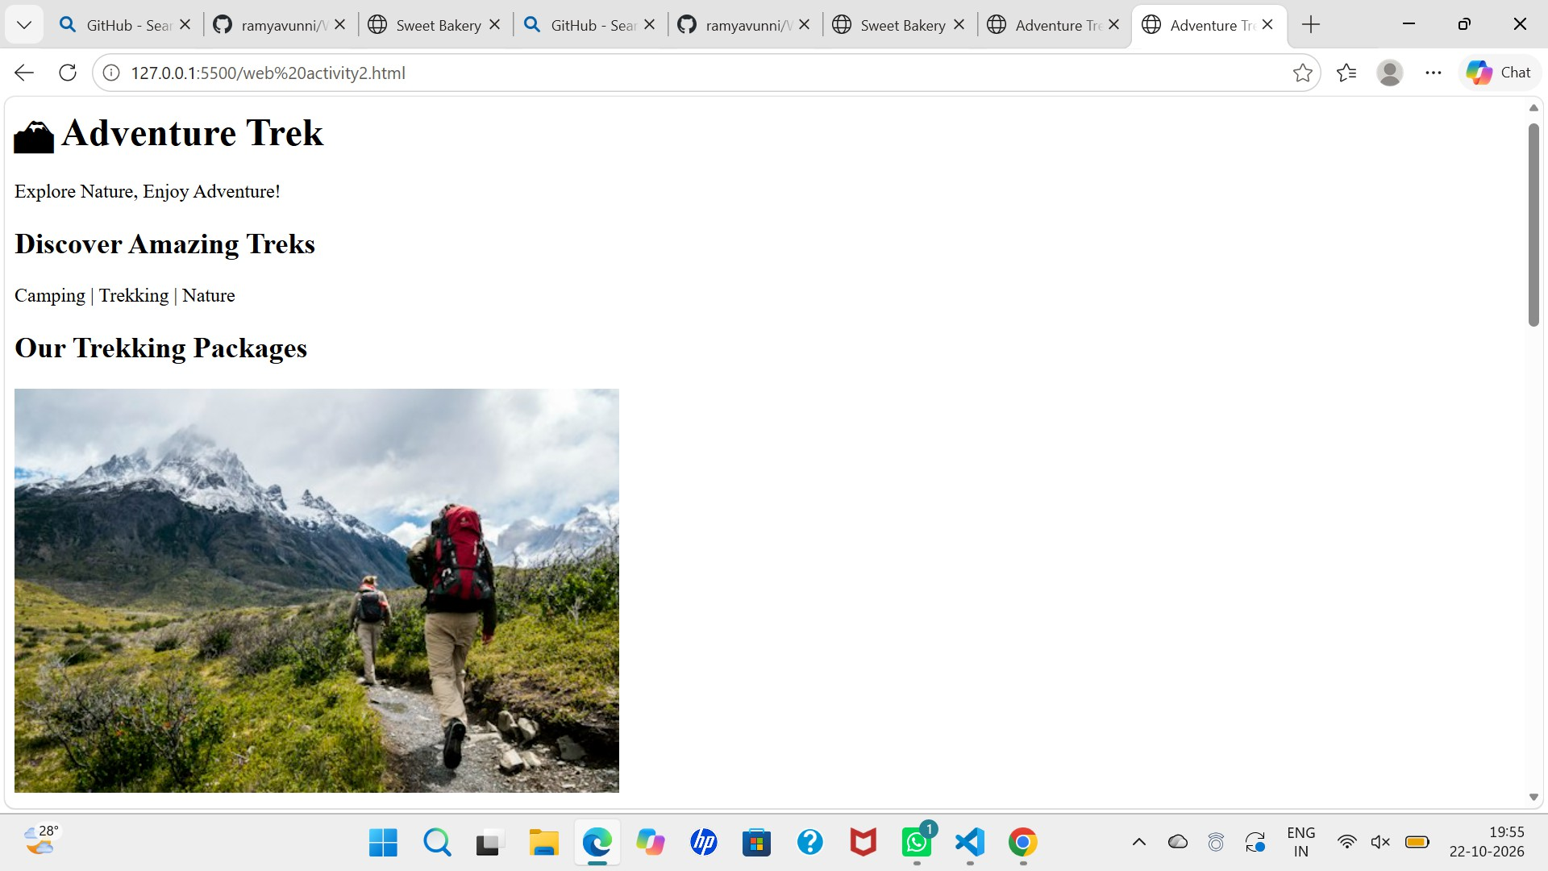

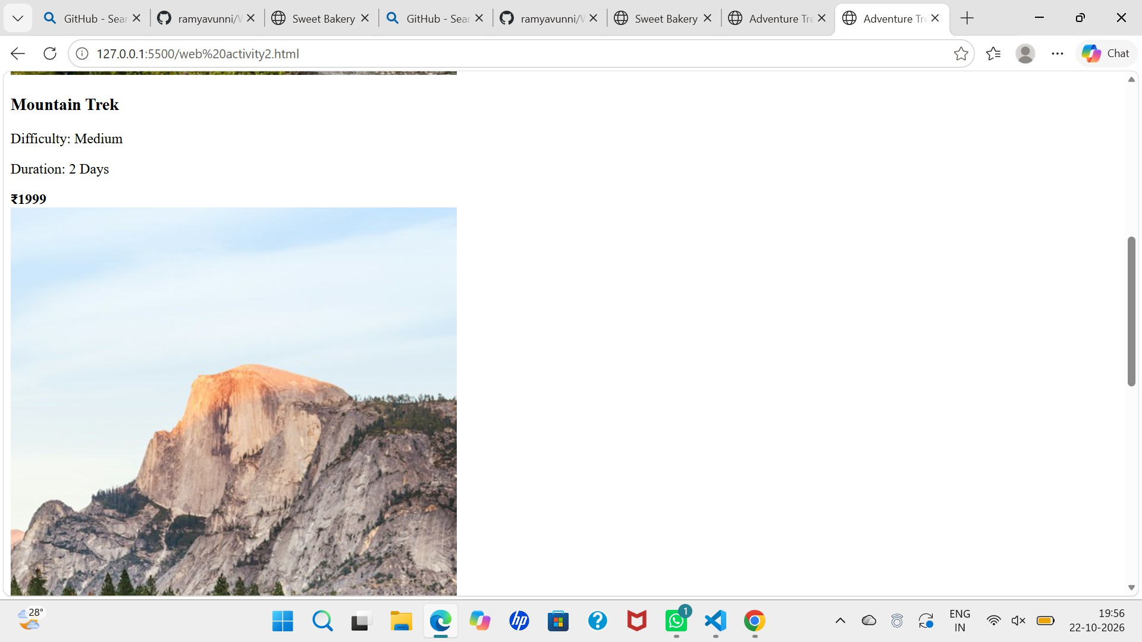

package.
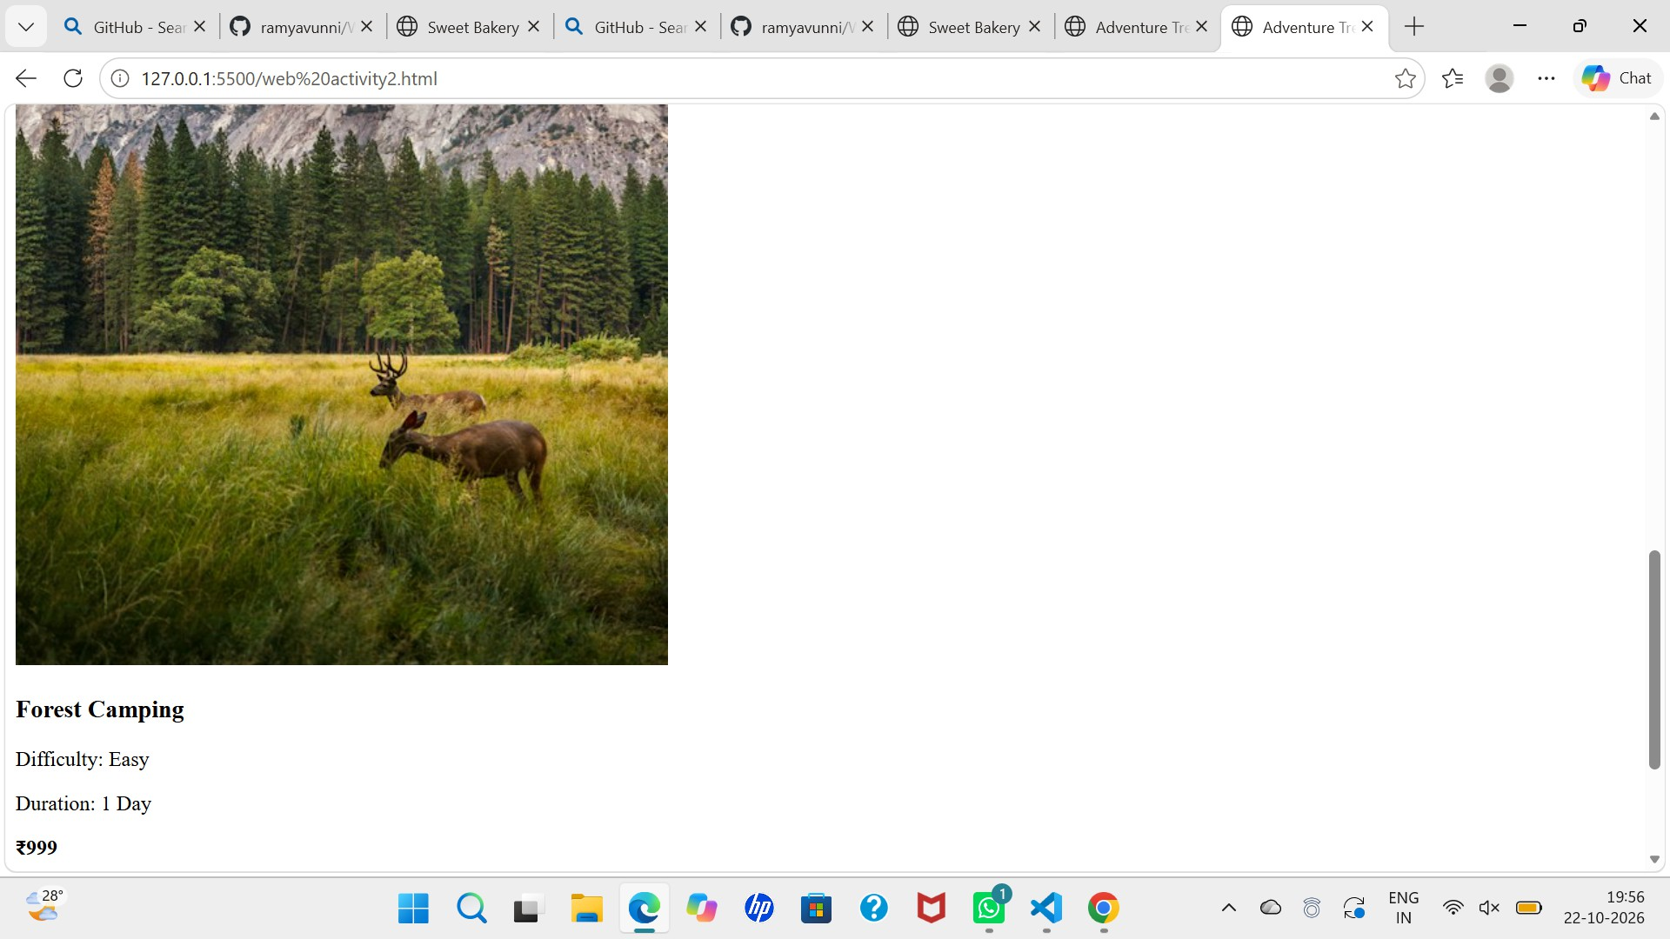

Screenshot 7: Adventure Trek website — equipment checklist and safety guidelines.
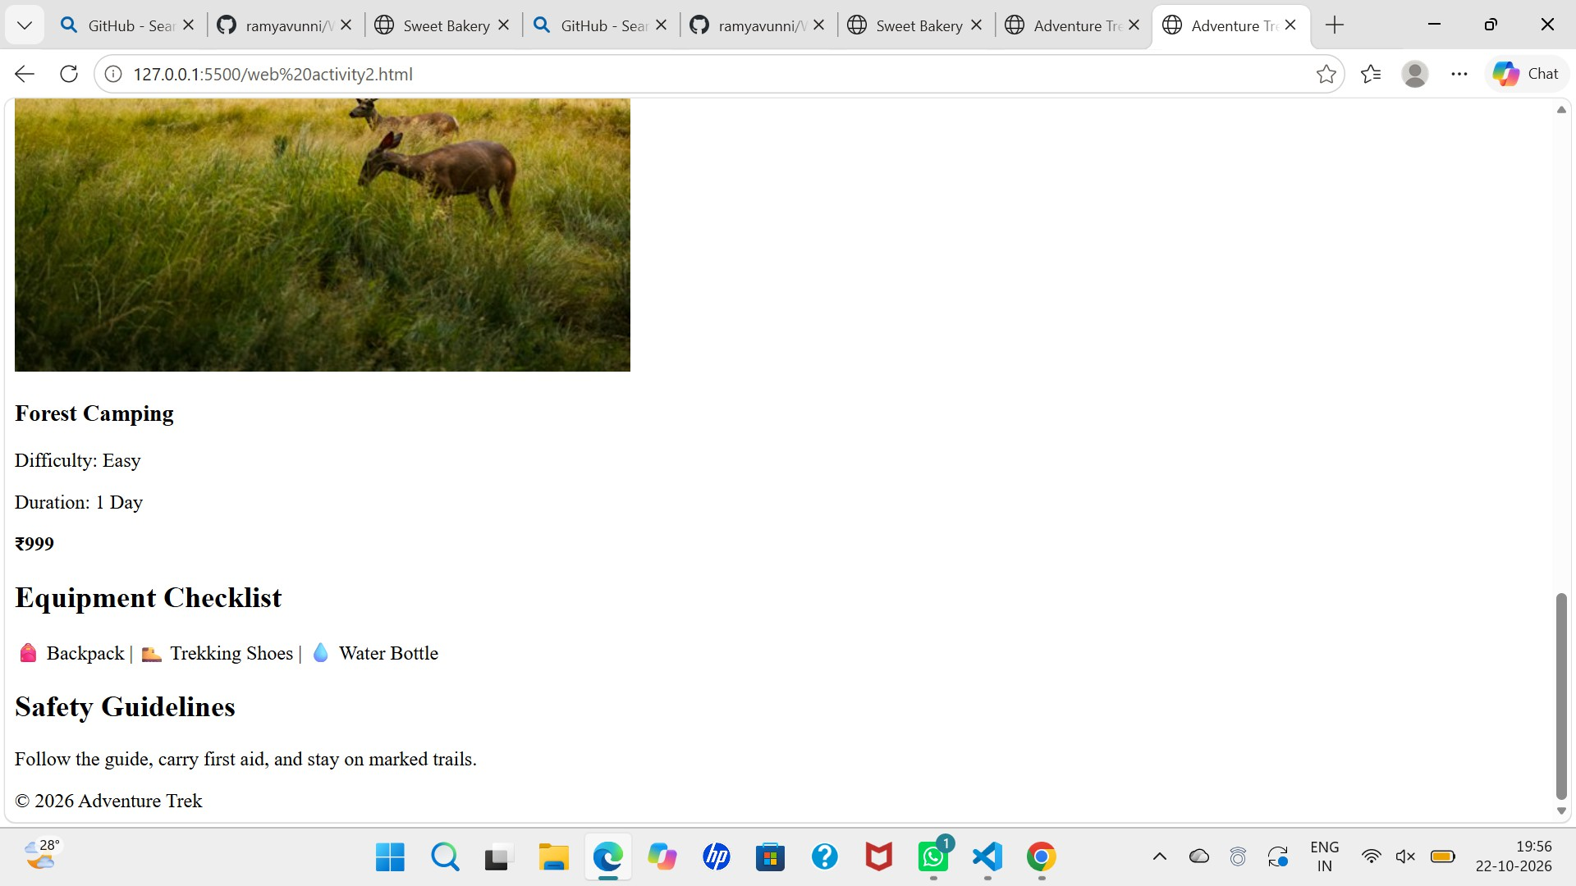

cards.


